**Product: Social Stock Analyzer**

**Team:** Gurpinder Singh, Nout Reusken, Mihika Marathe, Ojas Upadhye, Qiuxia Tang

**Sprint Completion Date:** 1/25/22

**Revision Number:** 4

**Revision Date:** 2/28/22

**Goal:** In this sprint, we want to create the log in, create an account, and home page screens. The home page will be empty with a few UI components. Log in / log out should be functional.

**Task Listing:**

* As a user, I want to be able to create an account and log in and out of it so I can maintain a portfolio of the stocks of my choosing without having to create a new one each time.(5)
  + Create a login page. - Gurpinder (4 hours)
  + Create a registration page. - Qiuxia (2 hours)
  + Connect logging in and registration to the database. - Ojas (3 hours)
  + Set up a user database to store user information and configure back to front end connection. - Ojas (3 hours)
* As a user, I want a home page where I can access all the applications’ features in one place. (3)
  + Set up a basic home page with buttons.- Mihika(4 hours)
* Infrastructure (3)
  + Set up Jira and Confluence. - Nout(2 hours)
  + Learn AWS and React. - Mihika(2 hours)

**Team Roles:**

Gurpinder Singh: Developer/Product Owner

Nout Reusken: Scrum Master

Mihika Marathe: Developer

Ojas Upadhye: Developer

Qiuxia Tang: Developer

**Initial Task Assignments**

Listed above.

**Burnup Chart:** 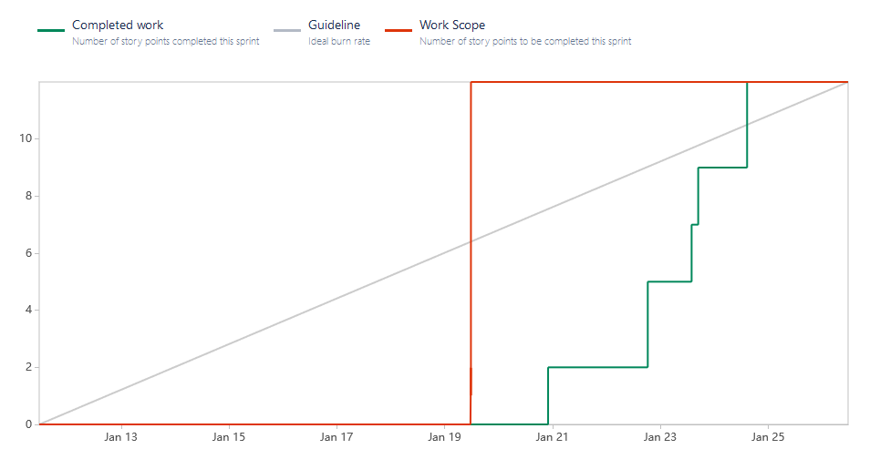

**Initial Scrum Board:** (task board, separate columns for tasks not started, tasks in progress, tasks completed)

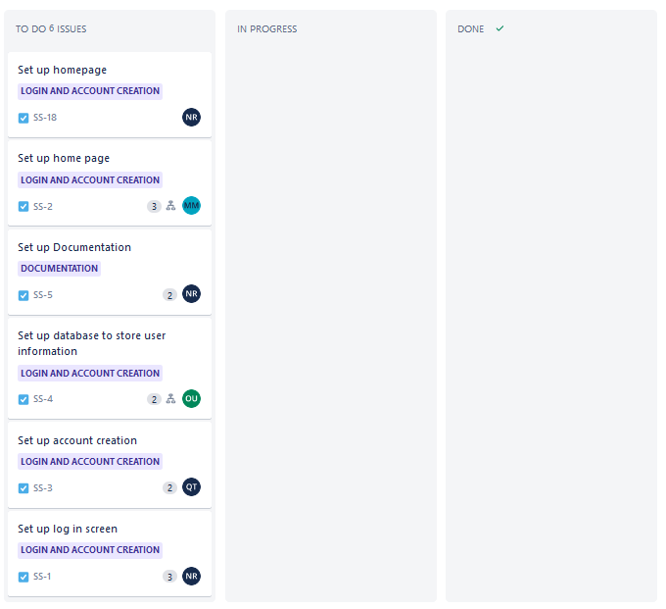

**Scrum Times:** (3 times that the team meets every week, including one with the TA)

1. Friday 4:30-5:15, meeting with TA
2. Tuesday 5-6ish
3. Sunday 2-3ish or 4-5ish